# 

# Lambgates Patient Participation Group

Venue: Lambgates Health Centre, Lower Ground Floor Meeting Room

Tuesday 12th March 2024

14:00-15:00pm

**Attendees:**

|  |  |  |  |  |
| --- | --- | --- | --- | --- |
|  |  |  |  |  |

**Apologies:**

|  |  |  |  |  |
| --- | --- | --- | --- | --- |
|  |  |  |  |  |

1. **Practice Update**

**Additional Clinical Space**

Over the past few weeks, our building has undergone significant renovations, with a particular focus on optimising our clinical spaces. The practice is thrilled to share that we have successfully converted one of our upstairs consulting rooms into three new clinical rooms. This transformation was undertaken to create additional space for our clinical staff, allowing us to increase our capacity and better serve our growing patient community. We believe this will contribute to reduced wait times and an overall improvement in the efficiency of our operations.

**Staff Changes**

It is with mixed emotions that we share the news that our Practice Manager, Sharon, has decided to take a new professional path closer to home, leading her to depart from Lambgates.

Sharon has been an integral part of our practice, bringing dedication, expertise, and a positive spirit to our team. Her contributions have played a significant role in our success, and she will be missed by all of us. We invite you to join us in expressing your best wishes for her future success and happiness.

Eleanor Thornalley will become the new Practice Manager of Lambgates from the 15th of April and we look forward to your continued support as we navigate through this change.

1. **PCN Update**

Stephanie White, one of our Pharmacy Technicians has left the team – we wish her all the best in her new role.

We have recently appointed a new pharmacy technician (Sandra Stone) to fill this vacancy along with an additional paramedic (Anna Booth) to join our existing team of Ben and Rich who will soon be working across the 5 practices in Glossop both in clinics and community visits.

1. **Pharmacy First**

Pharmacy First is a new NHS programme to enhance care navigation from GP practice staff. ET introduced the 7 clinical pathways currently accepted via the pharmacy first scheme. It was agreed that both the practice and the PPG attendees would gather feedback on how this is working and discuss it again at the next meeting.

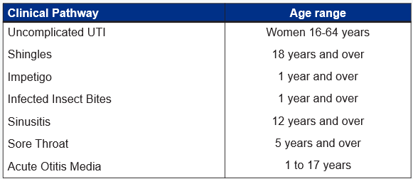

***Benefits of Pharmacy First***

*•To help with capacity in the practice so practice appointments can be used for patients who really need them*

*•To improve access for patients with minor illnesses*

*•To change patient behavior so they go to community pharmacy as the ‘first port of call’ for minor illness and medicines advice*

*•To support the integration of community pharmacy into the PCN team*

*•To create improved relationships between practices and community pharmacies to deliver high quality and integrated care to patients*

*•To help patients self-manage their health more effectively with the support of community pharmacists*

**Friends & Family**

**January 2024**

|  |  |
| --- | --- |
| Very Good | 162 |
| Good | 10 |
| Neither Good Nor Poor | 3 |
| Poor | 2 |
| Very Poor | 1 |
|  | 178 |

1. **PPG Notice Board**

CR and AB are planning to update one of the practice noticeboards on behalf of the PPG. CR and AB have diarised the 18th of April to come into to practice to do this. CR suggested a theme of ‘Don't be lonely’ by provide a range of local resources advertising all the local groups and events in and around Hadfield with some meaning full quotes for patients to take away. CR and AB are also going to use this opportunity to encourage other patients to join the PPG. CR explained that she was struggling to find local groups for Men. ET explained that the practice had recently received a staff presentation by Mentell, a charity that have recently opened a new hub in Glossop at Bredbury house. ET suggested that this could be added to the board and would provide some details on what they do and how they help. We look forward to sharing the notice board at our next meeting.

1. **Future Meeting Date**

The next PPG meeting will be held at Lambgates Health Centre, Lower Ground meeting room on Tuesday 18th June 2024 14:00-15:00pm. Please sign in at reception when you arrive. We look forward to seeing you.