**Lambgates Health Centre Practice Newsletter**

**Autumn 2022**

**Welcome to our Practice Newsletter**

Welcome to our new Lambgates Health Centre Newsletter. This contains Practice news, updates and wider primary care messages and announcements, which you can expect to receive going forward on a quarterly basis. We will continue to let you know of any upcoming events, or ways you can get involved in practice activities and how you can make a positive impact at your practice.

**Dr Amna Ahmed & Dr David Gilliland**

**GP Partners @ Lambgates Health** Centre

Why not follow us on facebook

<https://www.facebook.com/Lambgates>

**Lambgates Health Centre Website**

<https://www.lambgatessurgery.co.uk/>

**Latest news**

There has been lots of changes at Lambgates Health Centre since our last newsletter. We have said farewell to our long serving Partner Dr Lindsay Palmer who worked at the practice for over 25 years. We wish her all the very best in her retirement. We are pleased to inform you that Dr David Gilliland has joined the partnership at Lambgates Health centre from July 2022.

**Getting to know your team**

The practice is delighted to welcome our new junior doctors Dr Alice Thornton, Dr Usman Shoukat who are with us for 12 months and Dr Ffion Roblin and Dr Emily Whitehall who are with the team until December 2022.

The practice is also delighted to announce that our wonderful Receptionist/Phlebotomists Jessica Knowles has started a fantastic new career path with us and is now our Trainee Health Care Assistant. We are so proud of her development so far and cannot wait to see her evolve in her new role.

We also welcome several new members of reception /Administration team since our last newsletter and wish to welcome them all to Lambgates Health Centre, Christine, Mel , Dianne, Claire W , Julie and Claire K.

**Are you using the right services**

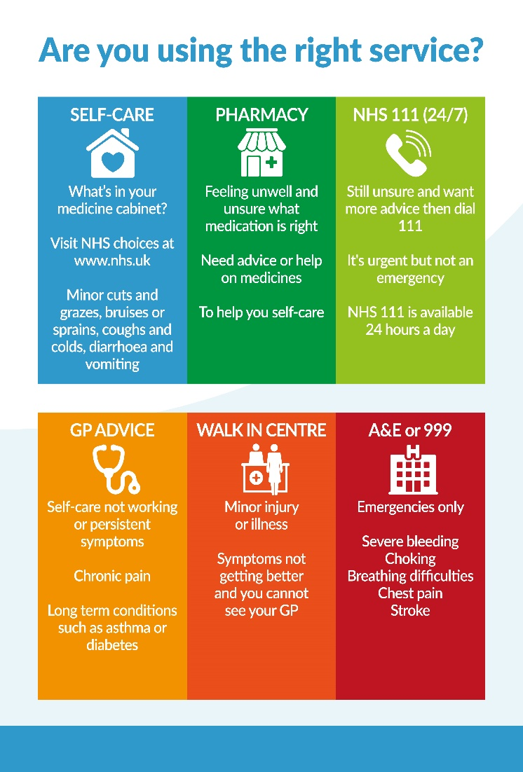

Thank you to everyone who completed one of our friends and family test questionnaires. Over the last quarter **95 %** of you who visited the practice said we were good or very good and would recommend us to their friends and family.

The NHS want you to have the best possible experience of care. The NHS Friends and Family Test is a way of gathering your feedback, so we can continually review our service.

Why not complete one here is the link:-<https://www.lambgatessurgery.co.uk/friends-family-test>

We know that finding the right place to go when you become ill or are injured can be confusing. By selecting the right service for your illness or injury, you're not only looking after your health but using NHS services responsibly, which is appreciated by all our local Practices and beyond

**REMEMBER YOUR LOCAL PHARMACIST!**

Any minor illness/health problem can be dealt with and by the your local NHS Community Pharmacist Consultation Service

♦ Bites/Stings (Bee stings/Wasps)

♦ Colds (coughs, colds, flu-like symptoms, sore throat) ♦ Congestion (blocked or runny nose, Hay fever, Excess mucus)

♦ Ear (Earache, ear wax, blocked ear, hearing problems)

♦ Eye (conjunctivitis, dry/sore tired eyes, red or irritable eyes, sticky eyes, eyelid problems, watery/runny eyes)

♦ Gastric/Bowel (Constipation, diarrhoea, infant colic, heartburn, indigestion, haemorrhoids, rectal pain, vomiting and nausea)

♦ General (Hay fever, sleep difficulties, tiredness)

♦ Gynae/Thrush (cystitis, thrush, vaginal itch or soreness)

♦ Pain (acute pain, ankle/foot pain, headache, hip/knee/leg/ wrist/hand/back pain/swelling, migraine, shoulder pain, sprains and strains

♦ Skin (acne, athletes foot, blisters, dermatitis, dry skin, hair loss, rash (allergy), ringworm/threadworm, scabies, warts/ verrucae, wound problems)

♦ Mouth/Throat (cold sore blisters, hoarseness, mouth ulcers, sore mouth, sore throat, oral thrush, teething, toothache)

Our Patient Participation Group (PPG)

Our PPG is a group of patients and GP Practice staff who meet to discuss Practice issues and patient experience to improve the service. The purpose of a PPG is to provide a means for patients to be more involved in the services they receive, to explore complaints and survey results, and to propose feedback for future developments and change. Being part of the PPG membership does not take up a lot of your time, but it can make a big difference. It gives you the opportunity to provide vital feedback which helps to develop the Practice services. Members of the PPG Committee meet once e every 6 weeks. There is also an Annual General Meeting which all patients are welcome to attend. Any registered member of the Practice can join the group, but there is a process to be followed if you wish to sign up. Please see this page on our website for more information:

[**https://www.lambgatessurgery.co.uk/patient-participation-group**](https://www.lambgatessurgery.co.uk/patient-participation-group)

**Our Online triage system**

It is no secret that GP Practices face increasing pressure to help patients get the right medical advice they need, as quickly as possible.

In a standard appointment system there are some on the day urgent appointments, a limited number of phone appointments, then routine appointments with a waiting time that is often 2-3 weeks. This means long waits for problems that should be dealt with sooner, and some people being turned away without their problem being addressed.

At Lambgates health Centre we pride ourselves on continually looking at new ways to improve our service and we recognise that the vast majority of our patients prefer the same day telephone consultation system we provide, there are others who would prefer a different type of access. Therefore, in order to ensure we meet the ever-increasing demand and needs of our patients whilst ensuring resources are utilised appropriately, we need to adapt the way we deliver care and look at new ways of supporting our patients.

We want to challenge the status quo and provide a more efficient service that enables patients to contact us digitally.

[**https://florey.accurx.com/p/C81106**](https://florey.accurx.com/p/C81106)

**Have you booked your flu jab yet?**

You can either book an appointment via patient access <https://www.patientaccess.com/>

or if you do not have the facility to do this please ring our reception team on 01457 869 090, Option 3, option 1

Our first clinic is: **Saturday 17th September 2022 at Lambgates Health Centre**

If you don't want one, or have already received it elsewhere please let us know so that we can stop sending you invites.

The autumn Covid booster programme starts in the week beginning 5 September with care home residents among the first to get jabs 🍂

The NHS will invite other eligible groups to book appointments for 12 September onwards. Please wait to be contacted.

Autumn booster eligibility:

▪older adult care home residents & staff

▪frontline health & social care workers

▪aged 50 and over

▪aged 5-49 in a clinical risk group, including pregnant women

▪household contacts of the immunosuppressed aged 5-49

▪unpaid carers aged 16-49

**Appointments will be available to book via the national booking system – see link below – if you need any help with this please ask a family member or contact reception on 01457869090**

[**https://www.nhs.uk/book-a-coronavirus-vaccination/find-a-vaccination-centre**](https://www.nhs.uk/book-a-coronavirus-vaccination/find-a-vaccination-centre)

Your feedback on this newsletter is welcomed, and we would also be delighted to hear of any ideas and content you would like to see in a future edition. You can send these via our practice website https://www.lambgatessurgery.co.uk/contact-us-form . We hope you enjoy this newsletter and look forward to the next copy in Winter

**.**